Media compatible pressure transmitters in LEGO format
Photo
Video
German Version

0

0
At a glance: Additional material:
- Especially small and robust construction
- Compensated and linearized in the
temperature range of -25 - +85 ° C
- Accuracy depending on the pressure range between 0.7 and 1.5% FS

AMSYS, January 2019. Most people think that pressure transmitters (ready-to-use pressure sensors) need to be steel-housed sensors. AMSYS shows new ways with its analog pressure transmitters in LEGO-size. These miniaturized transmitters present excellent features of performance, fit for all types of pressure and can be used in several fields of application.
The AMS 471X pressure sensors are industrial transmitters, calibrated and compensated in the industrial temperature range of -25 - +85 ° C, linearized and with a supply voltage up to 36 V. The total error depends on the pressure range and is between 0.7 and 1.5% FS over the entire temperature interval. The one-side media resistant transmitters come in a robust plastic package with easy screw connection.
The AMS 471X series are available for all types of pressure measurement methods, as absolute pressure, relative pressure or differential pressure sensors. They are available in the pressure ranges from 0-5 mbar to 0-2.0 bar. In addition, a bidirectional differential version is offered in the ranges of
± 5.0 mbar to ± 1.0 bar. This type allows measuring under and over pressure linearly.
Ultimately, barometric pressure can be measured with air pressure variants in the range from 700 to 1200 mbar. Sensors can also be calibrated custom-specifically to other pressure ranges on demand.
The sensor series AMS 471X consists in three different series with different analog signal outputs. They bear the designations AMS 4710 (10 V output), AMS 4711 (5 V output) and AMS 4712 (4 – 20 mA output). The new AMS 4710 completes the series of high performing industrial pressure transmitters in plastic housing.
Areas of application include, beside others, gas flow and back pressure measurement. The AMS 471X can also be used for level measurement for heights of 0 - 50 cm or more in open vessels. The absolute pressure sensor series AMS 471X are suitable for vacuum control as well as for barometric measurements.
The analog AMS 471X are smart pressure sensors in a new, robust housing. They are largely miniaturized and easy to install. The AMS 471X are available in different versions for differential, relative and absolute pressure measurements. They are available with a 5 V / 10 V voltage and a 4 to 20 mA current output, responding to industrial requirements for analog output.

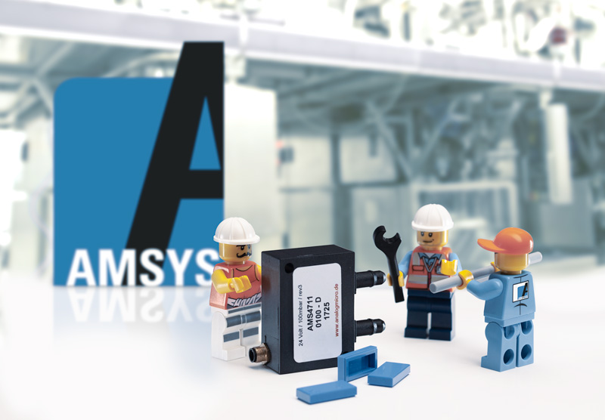
Pressure transmitter AMS 4711 in LEGO format

Kontakt AMSYS Kontakt Presseagentur
AMSYS GmbH & Co. KG awikom GmbH
Dr. Norbert Rauch Dr. Peter Stipp
An der Fahrt 4 Friedhofstraße 103
55124 Mainz 64625 Bensheim
Tel: +49 (0) 6131 / 4698750 Tel: +49 (0) 6251 / 17550-18
n.rauch@amsys.de peter.stipp@awikom.de
www.amsys.de www.awikom.de
Das Unternehmen

Firmenstrategie der AMSYS ist es, in direktem Kundenkontakt die jeweiligen Anwendungsprobleme möglichst mit Hilfe von Standardsensoren zu lösen. Dazu bietet das Unternehmen unter anderem ein umfangreiches Sortiment an innovativen OEM-Produkten an. Dieses umfasst im Schwerpunkt Drucksensorik analoge und/oder digitale Sensoren für alle Druckvarianten (Absolut-, Relativ- und Differenzdruck) von 5 mbar bis zu Drücken von 600 bar.
Über die Drucksensoren hinaus hat AMSYS das Angebot mit intelligenten Feuchtigkeits- und Temperatursensoren erweitert. Diese OEM-Sensoren sind durch äußerste Miniaturisierung gekennzeichnet und müssen zu den Top-High-Tech-Produkten gezählt werden. Für spezielle Anwendungen werden neben den OEM-Produkten auch fertig gehäuste Transmitter für den direkten Einsatz angeboten.
Durch die technische Kompetenz der Mitarbeiter und den guten Kontakt zu den Zulieferern können auch kundenspezifische Modifikationen der Standardprodukte angeboten werden, wodurch individuelle Problemlösungen möglich sind. Weitere Informationen unter www.amsys.de
Text und druckfähiges Bildmaterial unter pr.awikom.de/amsys

